Brute Force - Searching & String Matching
Sequential Search, Brute Force String Matching
Dr. R. Jeena
Sequential Search

Question 1
Write a program to implement Sequential Search to find a given element in an array.
Input:
Array: 12, 25, 8, 45, 32, 19, 50
Key: 32
Output:
Element found at position 5
Number of comparisons = 5

Question 2
Implement Sequential Search for an unsuccessful search.
Input:
Array: 5, 10, 15, 20, 25, 30, 35
Key: 18
Output:
Element not found
Number of comparisons = 7

Question 3
Write a program to find the first occurrence of an element using Sequential Search.
Input:
Array: 10, 25, 15, 25, 30, 25, 40
Key: 25
Output:
First occurrence at position 2

Question 4
Implement Sequential Search to find all occurrences of a given element.
Input:
Array: 7, 12, 7, 25, 18, 7, 30, 7
Key: 7
Output:
Occurrences at positions:
1, 3, 6, 8
Total occurrences = 4

Question 5
Write a program to count:
- Total comparisons
- Total matches
- Total mismatches
during Sequential Search.
Input:
Array: 3, 6, 9, 12, 15, 18, 21
Key: 15

Question 6
Implement Sentinel Sequential Search and compare it with ordinary Sequential Search.
Input:
Array: 14, 9, 22, 35, 18, 41, 27
Key: 18
Output:
Position found
Comparison count

Question 7
Write a program to perform Sequential Search on an array of student register numbers.
Input:
Register Numbers:
101, 102, 103, 104, 105, 106
Search Key: 104
Output:
Register Number found at position 4

Question 8
Implement Sequential Search for string data.
Input:
Names:
Anu, Bala, Charan, Deepa, Esha, Farhan

Search Name:
Deepa
Output:
Name found at position 4

Question 9
Write a program to perform Sequential Search on a 2-D matrix.
Input:
12 8 15
5 18 27
9 11 24

Key = 24
Output:
Element found at Row 3 Column 3

Question 10
Implement Sequential Search and analyze its performance.
Input:
Array:
45, 23, 67, 12, 89, 34, 56, 78, 90, 11,
29, 73, 18, 64, 37

Search Keys:
73
18
100
Tasks:
- Show each comparison.
- Count comparisons for every search.
- Identify best, average, and worst cases.
- Determine:
  - Best-case complexity
  - Average-case complexity
  - Worst-case complexity
  - Space complexity

Brute Force String Matching

Question 1
Implement the Brute Force String Matching Algorithm to search for a pattern in a given text.
Input:
- Text = "AABAACAADAABAABA"
- Pattern = "AABA"
Output:
- Position(s) where the pattern occurs.
- Total number of comparisons.

Question 2
Write a program to find all occurrences of a pattern in a text using Brute Force String Matching.
Input:
- Text = "BANANABANANA"
- Pattern = "ANA"
Output:
- Occurrences at positions 1, 3, 7, 9.

Question 3
Implement Brute Force String Matching and display the comparison table for each alignment.
Input:
- Text = "MISSISSIPPI"
- Pattern = "ISSI"
Output:
- Shift number
- Comparisons made
- Match/Mismatch result

Question 4
Write a program to count:
- Total character comparisons
- Total matches
- Total mismatches
during Brute Force String Matching.
Input:
- Text = "ABABABABAB"
- Pattern = "ABAB"

Question 5
Implement Brute Force String Matching and determine whether the search is:
- Best Case
- Average Case
- Worst Case
Input:
- Text = "AAAAAAAAAB"
- Pattern = "AAAAB"
Display the number of comparisons performed.

Question 6
Write a program that searches for a pattern in a text and reports the first occurrence only using Brute Force String Matching.
Input:
- Text = "COMPUTERSCIENCE"
- Pattern = "SCI"
Output:
- First occurrence position
- Number of comparisons

Question 7
Implement Brute Force String Matching for case-insensitive searching.
Input:
- Text = "DataStructuresAndAlgorithms"
- Pattern = "ALGORITHMS"
Output:
- Pattern found position

Question 8
Write a program to compare the execution of Brute Force String Matching for:
- Successful search
- Unsuccessful search
Input:
- Text = "PROGRAMMINGLAB"
- Pattern 1 = "LAB"
- Pattern 2 = "TEST"
Display the comparison count for both cases.

Question 9
Implement Brute Force String Matching and display every alignment of the pattern with the text.
Input:
- Text = "ABCDABCABCDA"
- Pattern = "ABCDA"
Output:
- Alignment number
- Matching result
- Pattern occurrence positions

Question 10
Write a complete program for Brute Force String Matching and perform complexity analysis.
Input:
- Text = "TTATAGATCTCGTATTCTTTATAGATCTCCTATTCTT"
- Pattern = "TATCTT"
Tasks:
- Find all occurrences of the pattern.
- Count total comparisons.
- Display the shifting process.
- Analyze:
  - Best-case complexity
  - Worst-case complexity
  - Space complexity

1. arr = [12, 25, 8, 45, 32, 19, 50]
key = 32

comparisons = 0
found = False

for i in range(len(arr)):
comparisons += 1
if arr[i] == key:
print("Element found at position", i + 1)
print("Number of comparisons =", comparisons)
found = True
break

if not found:
print("Element not found")
print("Number of comparisons =", comparisons)
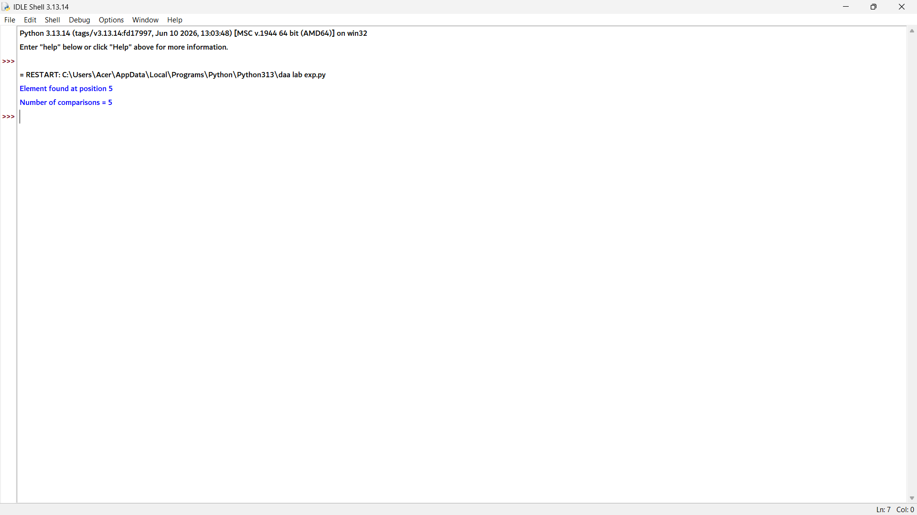

2. arr = [5, 10, 15, 20, 25, 30, 35]
key = 18

comparisons = 0
found = False

for i in range(len(arr)):
comparisons += 1
if arr[i] == key:
print("Element found at position", i + 1)
print("Number of comparisons =", comparisons)
found = True
break

if not found:
print("Element not found")
print("Number of comparisons =", comparisons)
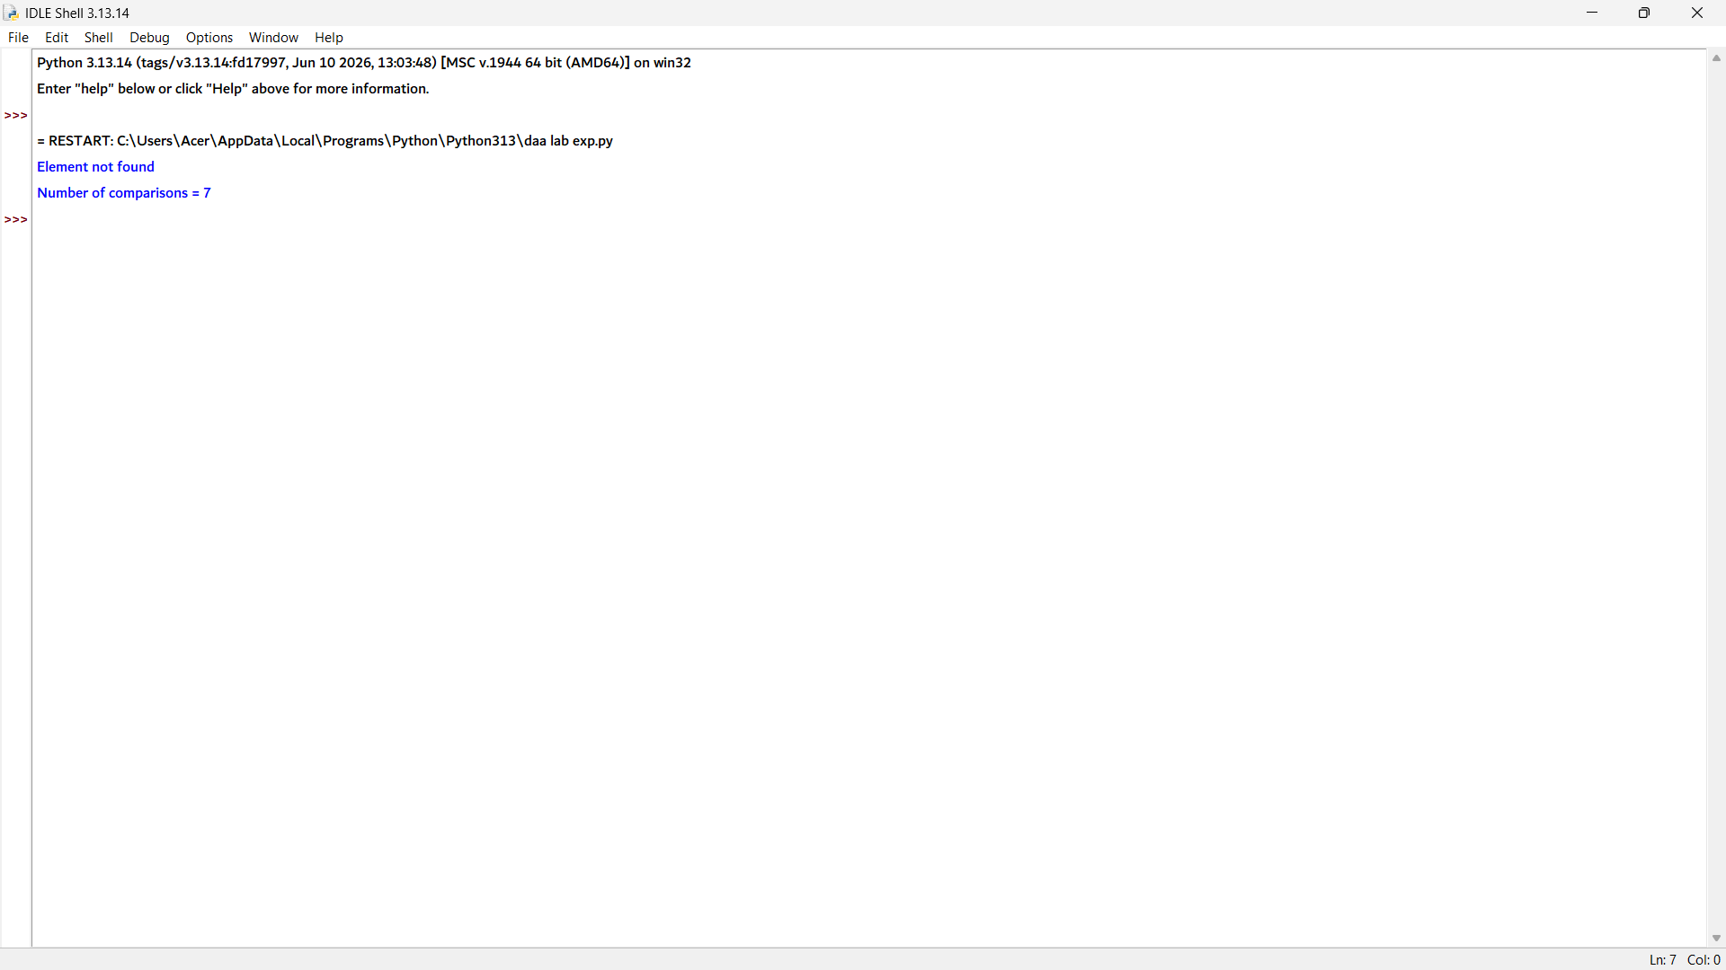

3. arr = [10, 25, 15, 25, 30, 25, 40]
key = 25

found = False

for i in range(len(arr)):
if arr[i] == key:
print("First occurrence at position", i + 1)
found = True
break

if not found:
print("Element not found")
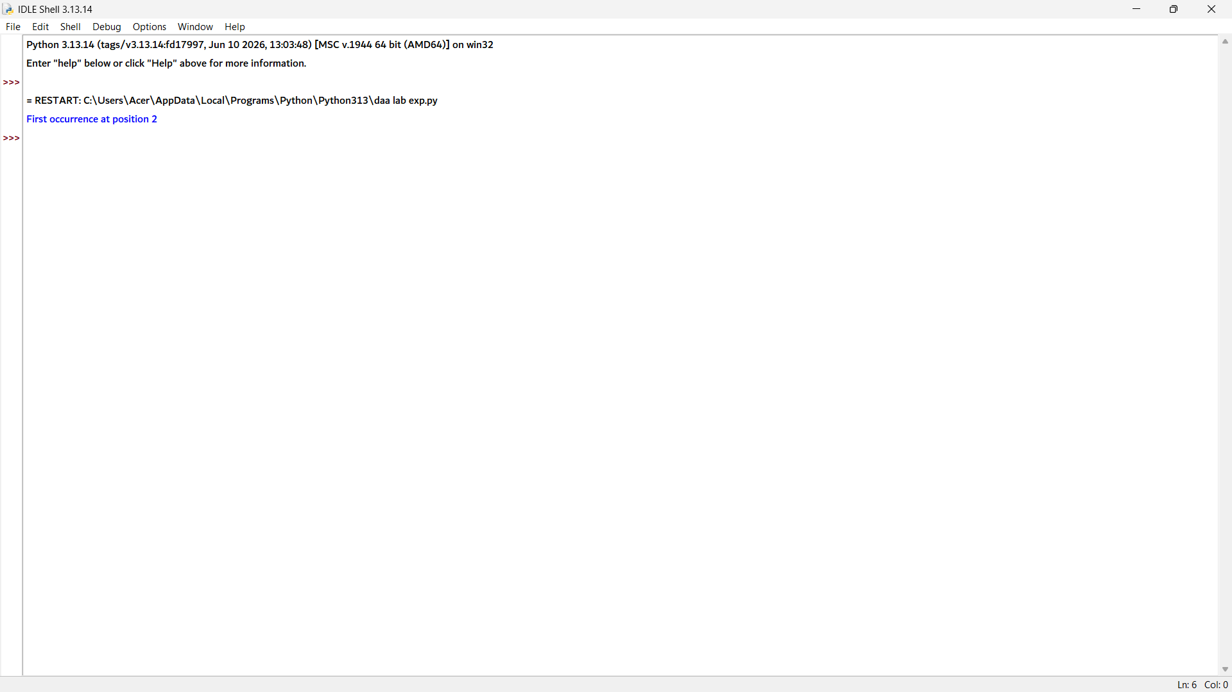

4. arr = [7, 12, 7, 25, 18, 7, 30, 7]
key = 7

count = 0

print("Occurrences at positions:")

for i in range(len(arr)):
if arr[i] == key:
print(i + 1, end=" ")
count += 1

print("\nTotal occurrences =", count)
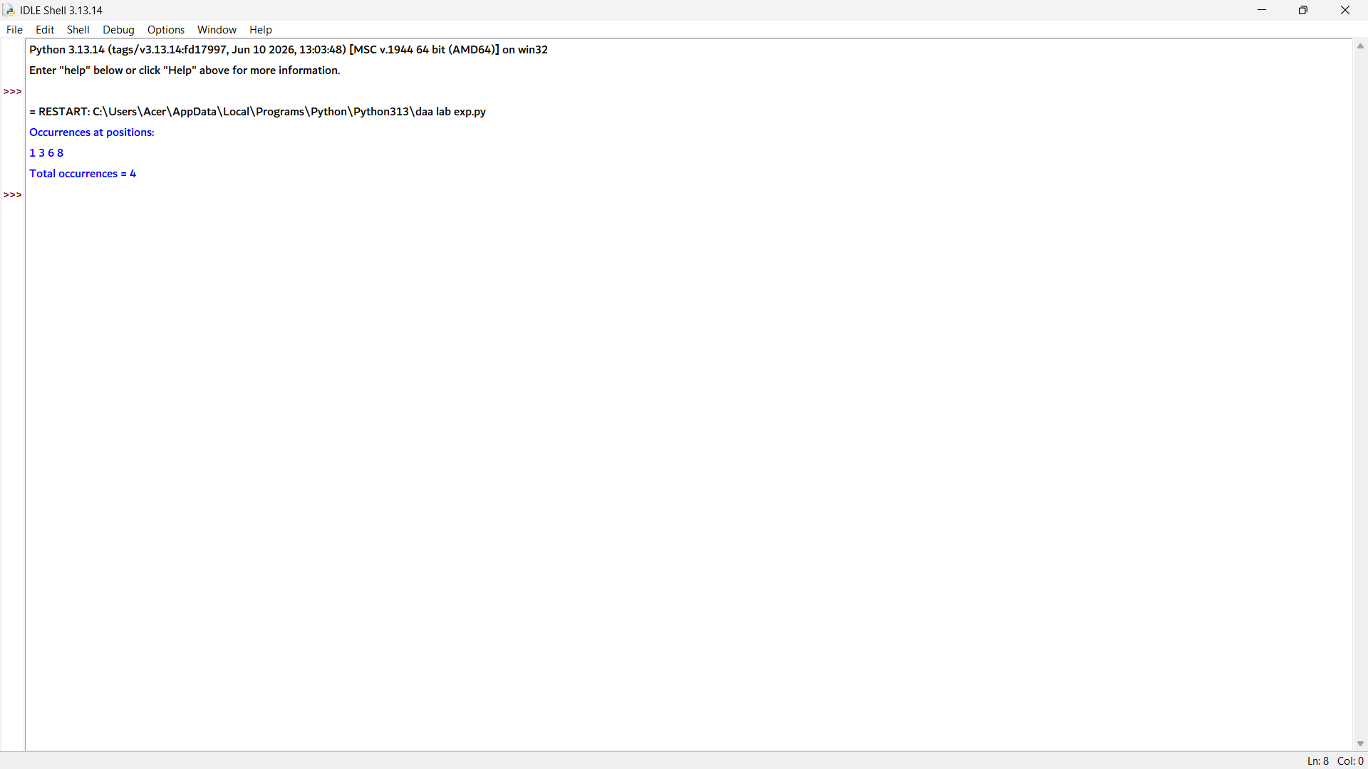
5. arr = [3, 6, 9, 12, 15, 18, 21]
key = 15

comparisons = 0
matches = 0
mismatches = 0

for i in range(len(arr)):
comparisons += 1

if arr[i] == key:
matches += 1
print("Element found at position", i + 1)
break
else:
mismatches += 1

print("Total comparisons =", comparisons)
print("Total matches =", matches)
print("Total mismatches =", mismatches)
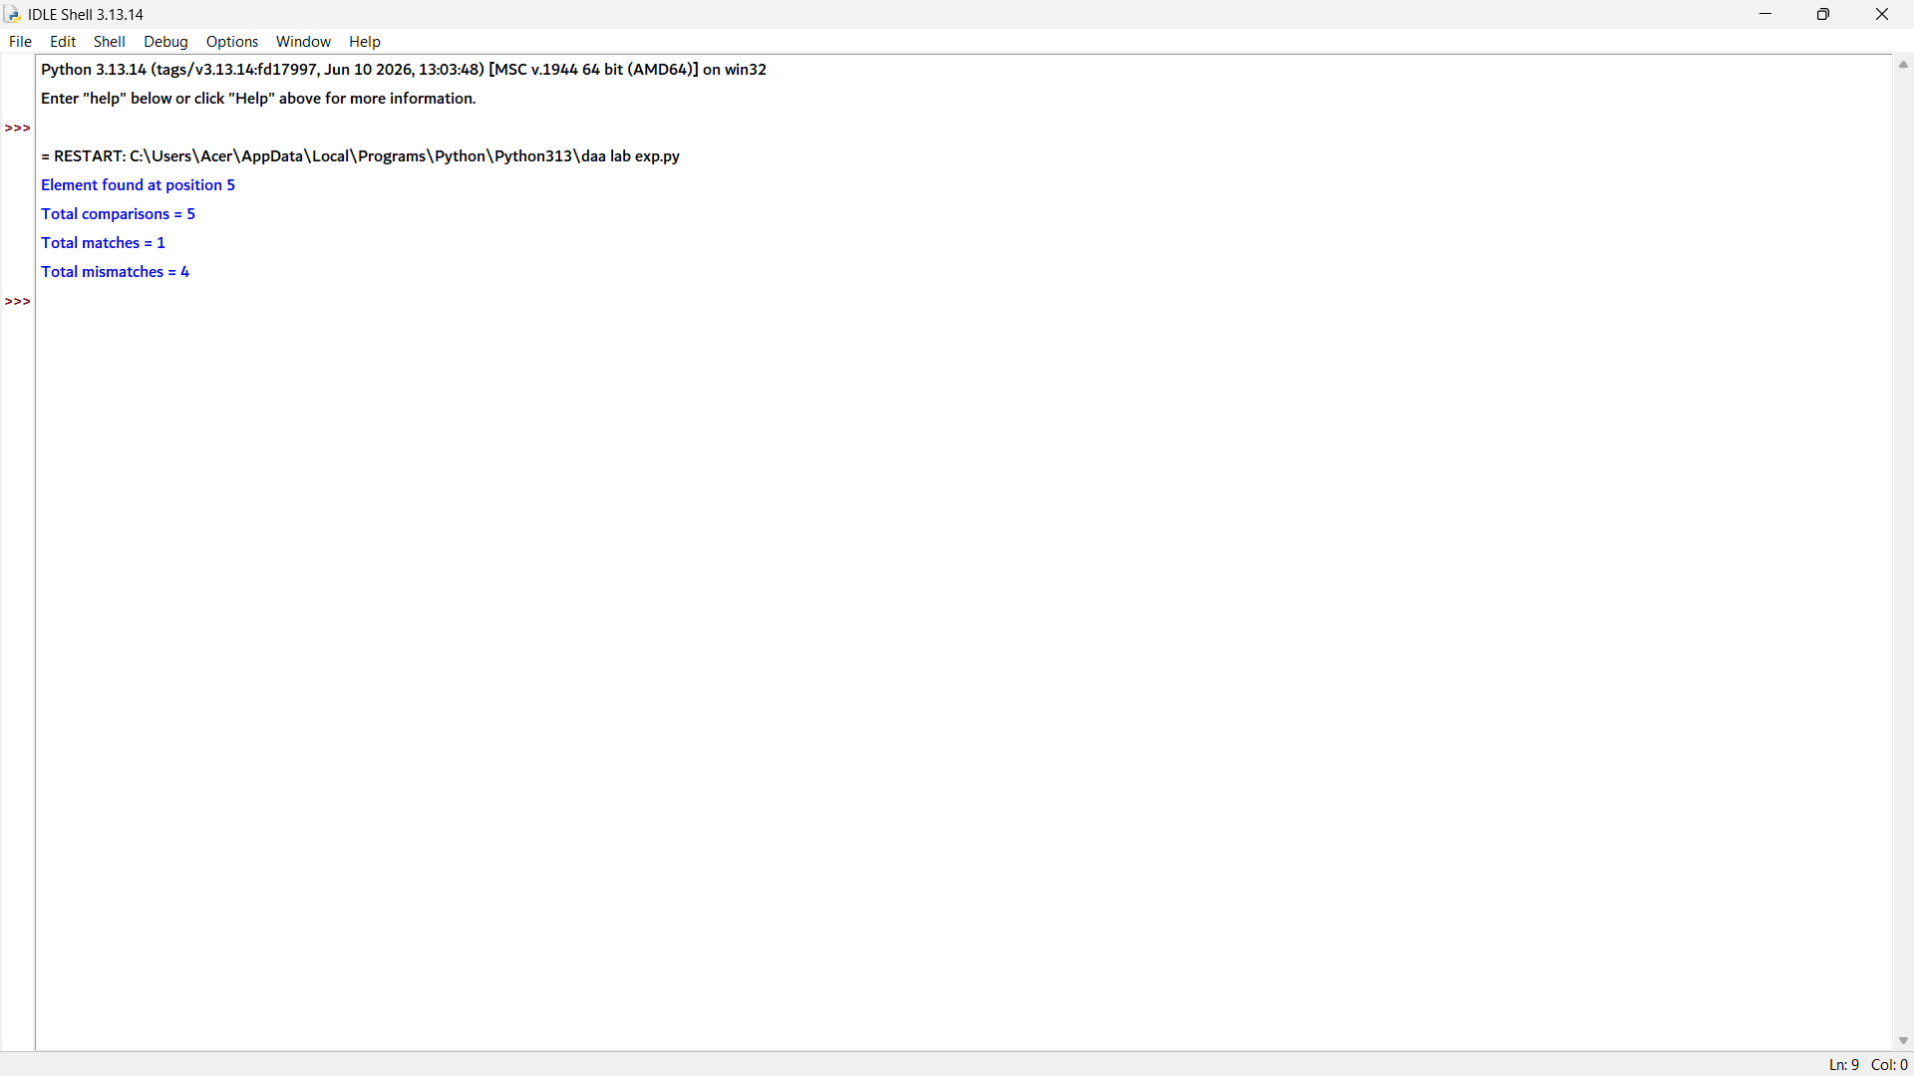

6. # Ordinary Sequential Search
def ordinary_search(arr, key):
comparisons = 0

for i in range(len(arr)):
comparisons += 1
if arr[i] == key:
return i + 1, comparisons

return -1, comparisons

# Sentinel Sequential Search
def sentinel_search(arr, key):
arr = arr[:] # Copy the array
n = len(arr)

arr.append(key) # Add sentinel
i = 0
comparisons = 0

while arr[i] != key:
comparisons += 1
i += 1

comparisons += 1

if i == n:
return -1, comparisons
else:
return i + 1, comparisons

# Input
arr = [14, 9, 22, 35, 18, 41, 27]
key = 18

# Ordinary Search
pos1, comp1 = ordinary_search(arr, key)

# Sentinel Search
pos2, comp2 = sentinel_search(arr, key)

print("Ordinary Sequential Search")
if pos1 != -1:
print("Position found:", pos1)
else:
print("Element not found")
print("Comparison count =", comp1)

print("\nSentinel Sequential Search")
if pos2 != -1:
print("Position found:", pos2)
else:
print("Element not found")
print("Comparison count =", comp2)
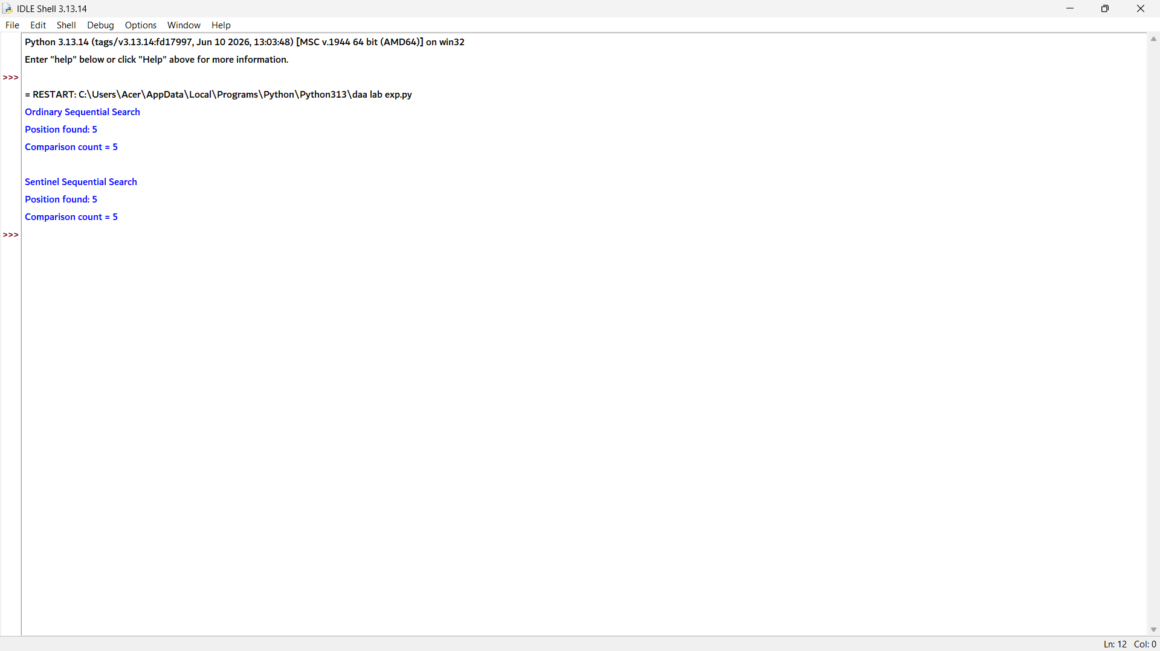

7. arr = [101, 102, 103, 104, 105, 106]
key = 104

found = False

for i in range(len(arr)):
if arr[i] == key:
print("Register Number found at position", i + 1)
found = True
break

if not found:
print("Register Number not found")

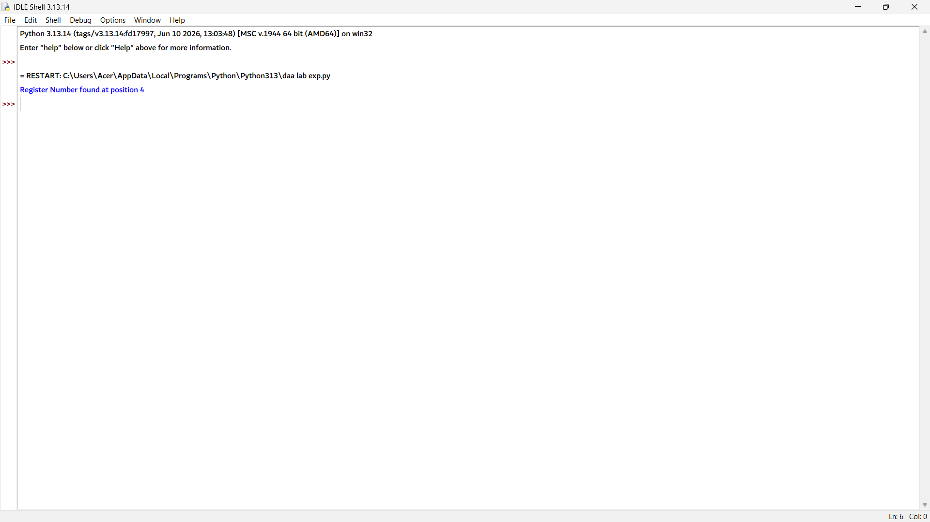

8. names = ["Anu", "Bala", "Charan", "Deepa", "Esha", "Farhan"]
key = "Deepa"

found = False

for i in range(len(names)):
if names[i] == key:
print("Name found at position", i + 1)
found = True
break

if not found:
print("Name not found")

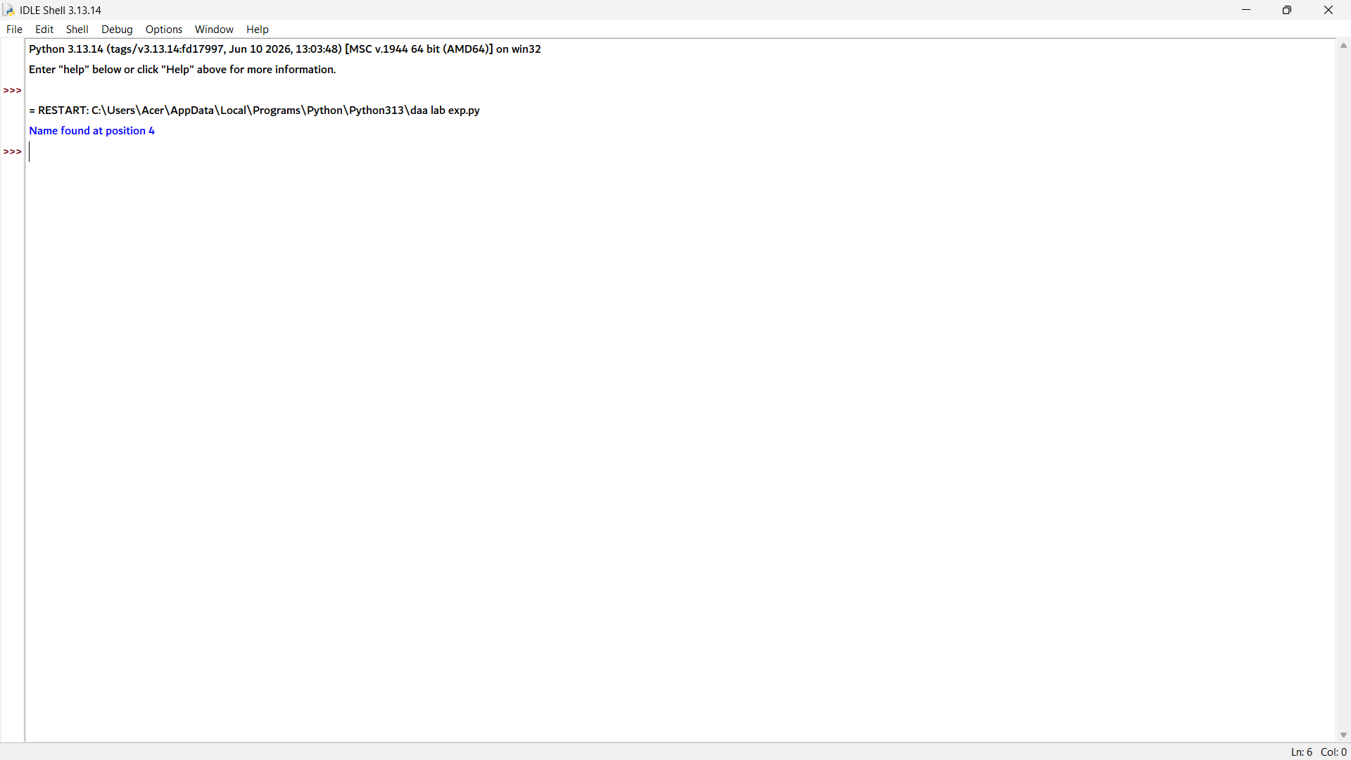

9. matrix = [
[12, 8, 15],
[5, 18, 27],
[9, 11, 24]
]

key = 24
found = False

for i in range(len(matrix)):
for j in range(len(matrix[i])):
if matrix[i][j] == key:
print("Element found at Row", i + 1, "Column", j + 1)
found = True
break
if found:
break

if not found:
print("Element not found")
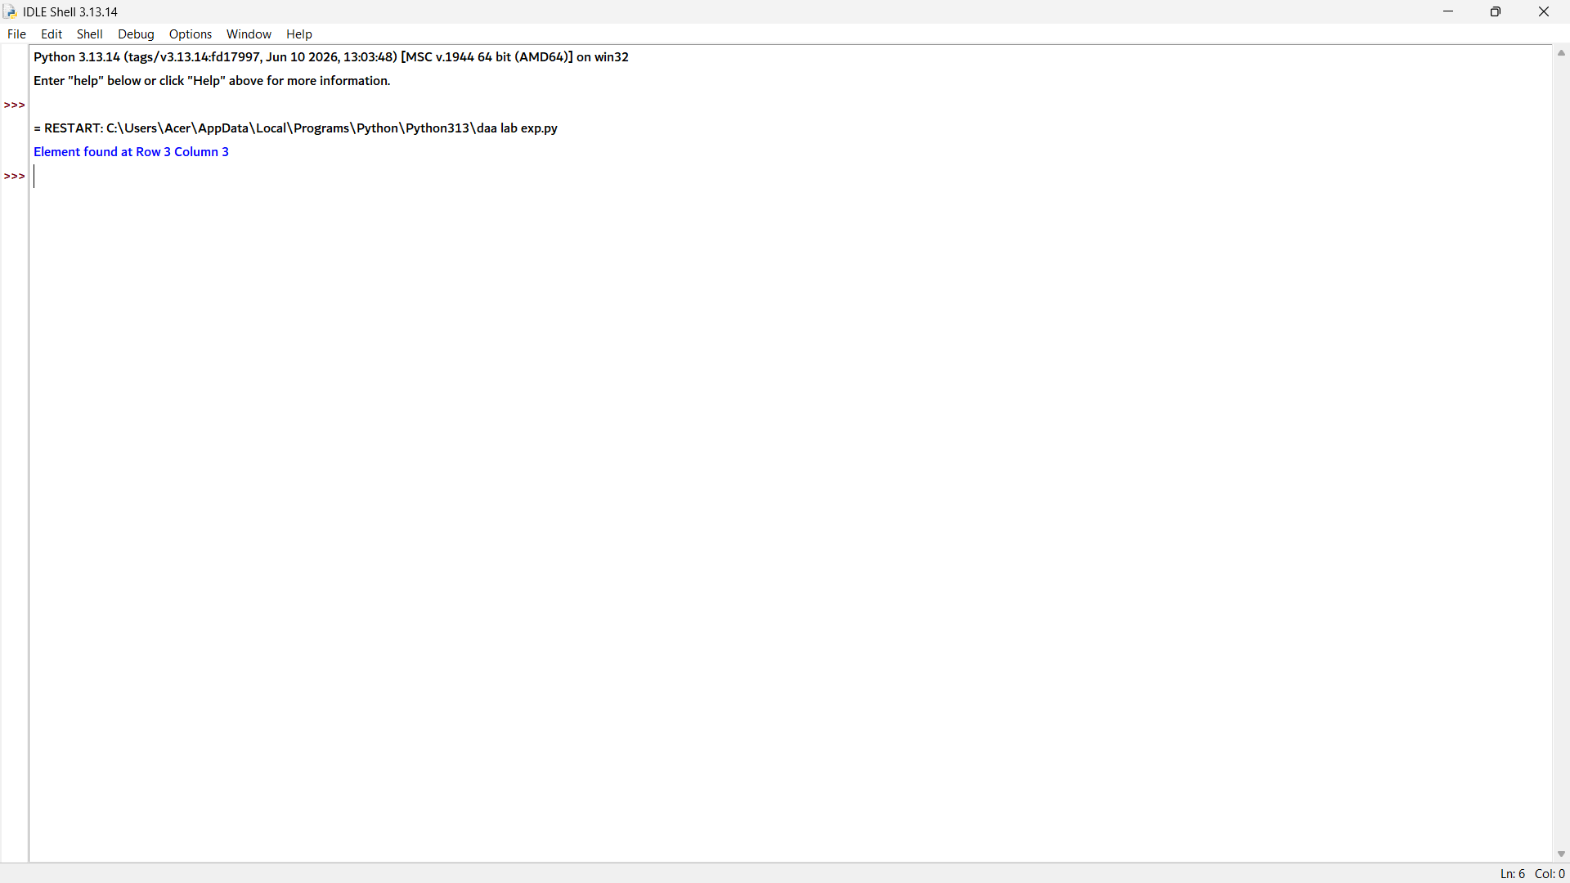

10. arr = [45, 23, 67, 12, 89, 34, 56, 78, 90, 11,
29, 73, 18, 64, 37]

keys = [73, 18, 100]

for key in keys:
comparisons = 0
found = False

for i in range(len(arr)):
comparisons += 1
if arr[i] == key:
print("Search Key:", key)
print("Element found at position", i + 1)
print("Number of comparisons =", comparisons)
found = True
break

if not found:
print("Search Key:", key)
print("Element not found")
print("Number of comparisons =", comparisons)

print()

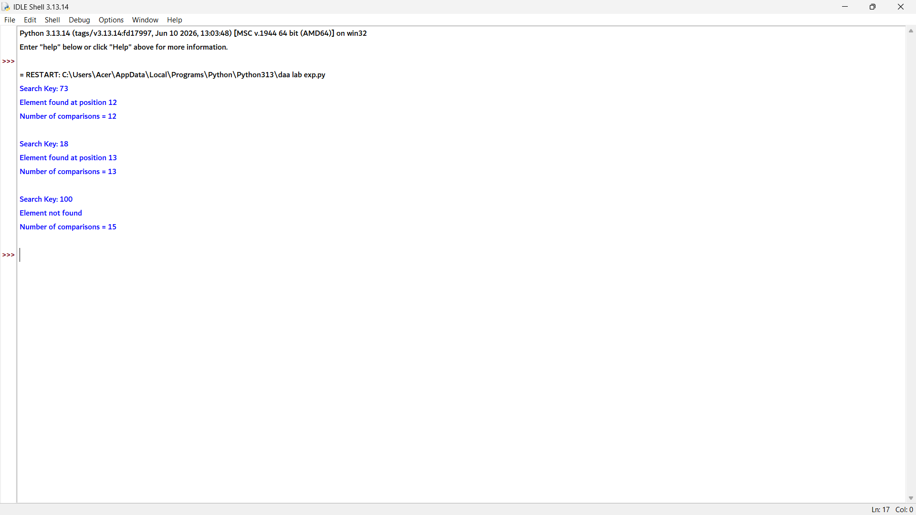

Brute Force String Matching
1. text = "AABAACAADAABAABA"
pattern = "AABA"

positions = []
comparisons = 0

n = len(text)
m = len(pattern)

for i in range(n - m + 1):
match = True

for j in range(m):
comparisons += 1
if text[i + j] != pattern[j]:
match = False
break

if match:
positions.append(i)

print("Position(s) where the pattern occurs:", positions)
print("Total number of comparisons:", comparisons)

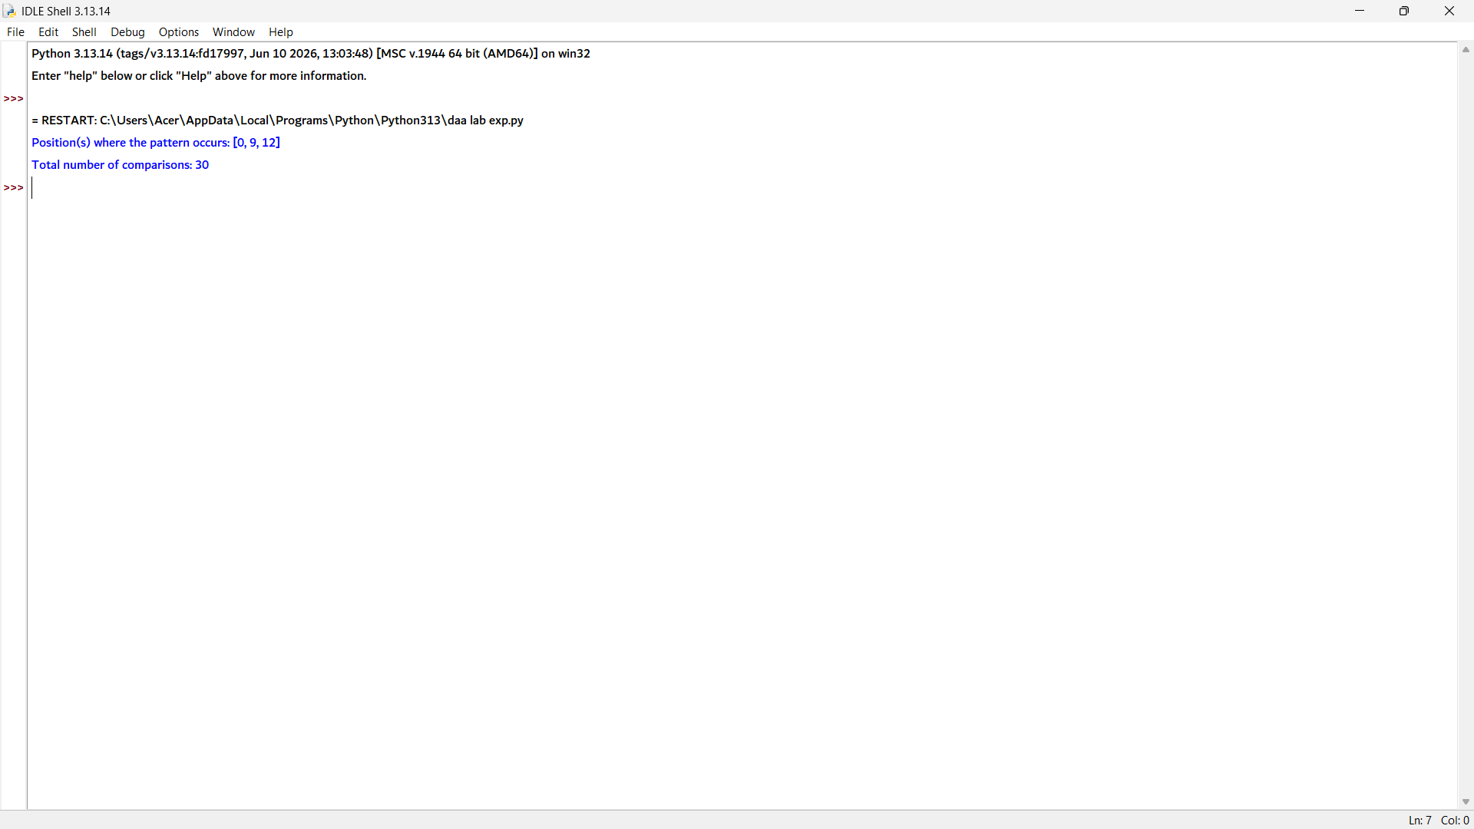
2. text = "BANANABANANA"
pattern = "ANA"

positions = []

n = len(text)
m = len(pattern)

for i in range(n - m + 1):
match = True

for j in range(m):
if text[i + j] != pattern[j]:
match = False
break

if match:
positions.append(i + 1) # 1-based position

print("Occurrences at positions:")
print(*positions, sep=", ")

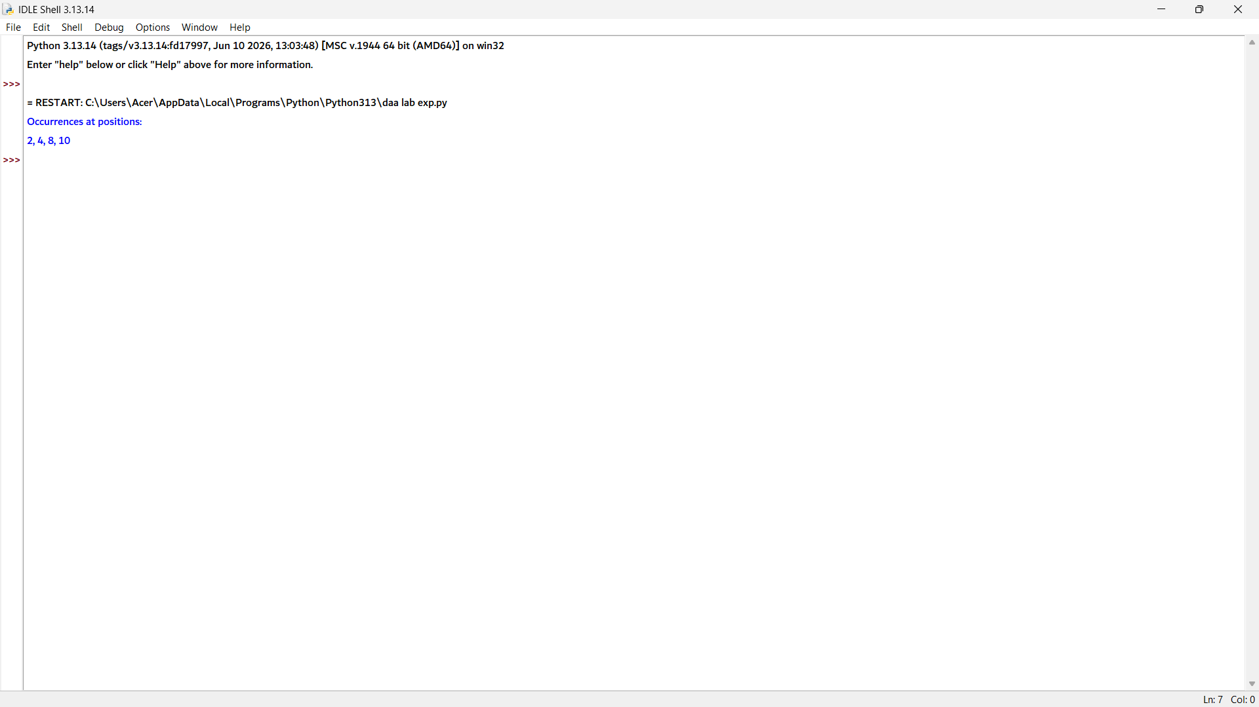

3. text = "MISSISSIPPI"
pattern = "ISSI"

n = len(text)
m = len(pattern)

print("Shift\tComparisons\tResult")

for i in range(n - m + 1):
comparisons = 0
match = True

for j in range(m):
comparisons += 1
if text[i + j] != pattern[j]:
match = False
break

if match:
print(i, "\t", comparisons, "\t\tMatch")
else:
print(i, "\t", comparisons, "\t\tMismatch")

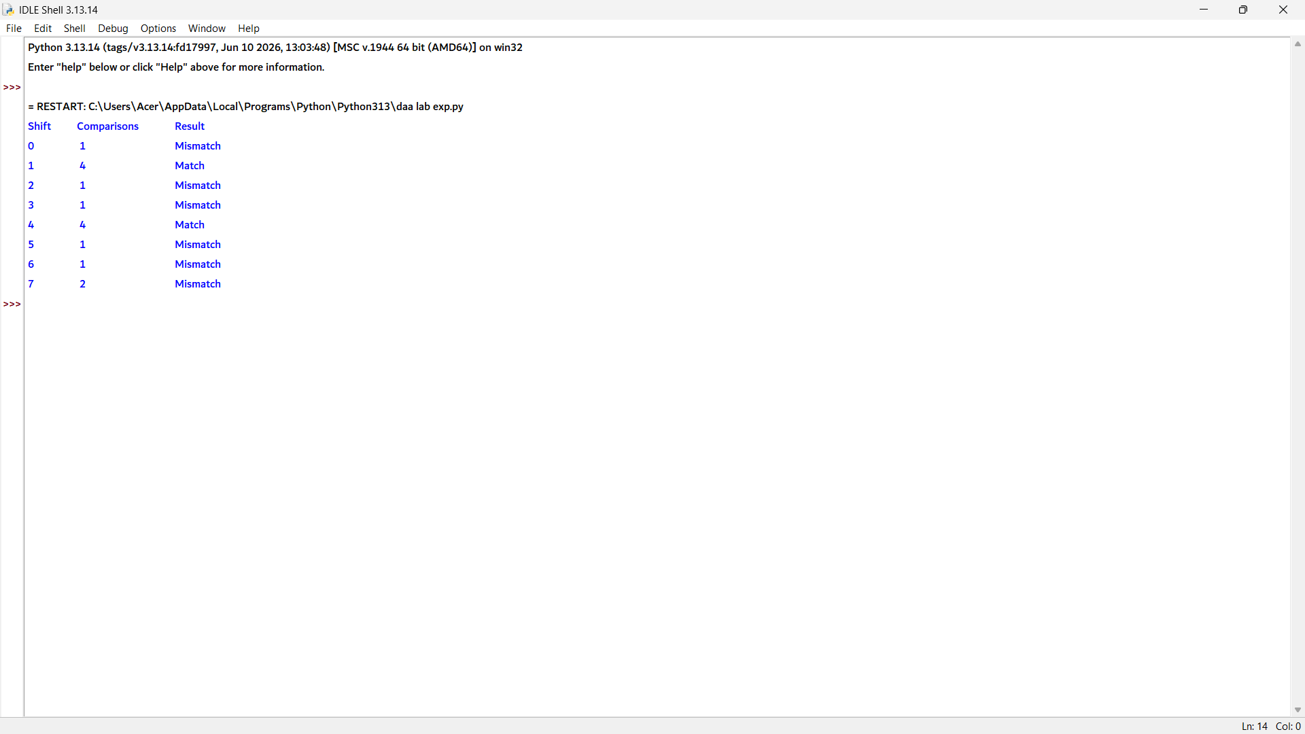

4. text = "ABABABABAB"
pattern = "ABAB"

comparisons = 0
matches = 0
mismatches = 0

n = len(text)
m = len(pattern)

for i in range(n - m + 1):
match = True

for j in range(m):
comparisons += 1

if text[i + j] == pattern[j]:
matches += 1
else:
mismatches += 1
match = False
break

print("Total character comparisons =", comparisons)
print("Total matches =", matches)
print("Total mismatches =", mismatches)

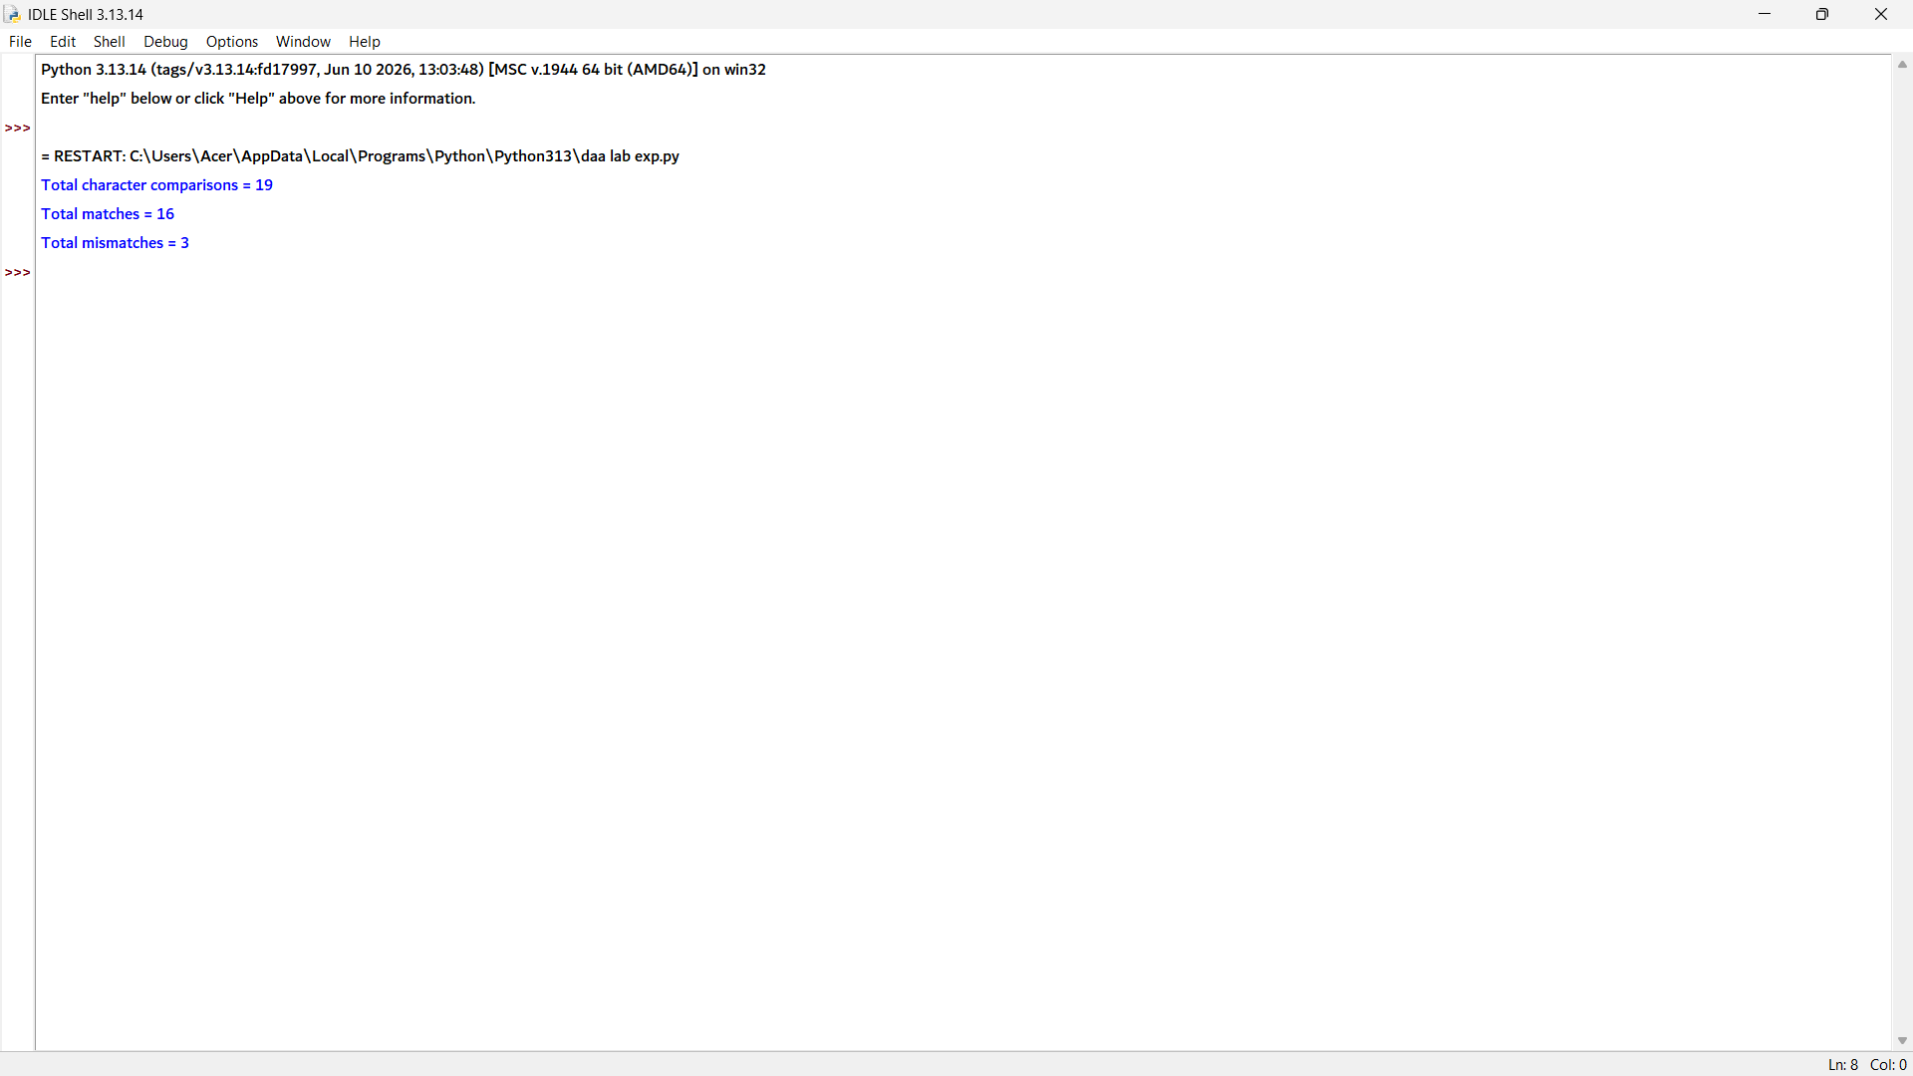

5. text = "AAAAAAAAAB"
pattern = "AAAAB"

n = len(text)
m = len(pattern)

comparisons = 0
found = False

for i in range(n - m + 1):
match = True

for j in range(m):
comparisons += 1
if text[i + j] != pattern[j]:
match = False
break

if match:
print("Pattern found at position", i + 1)
found = True

print("Total comparisons =", comparisons)

# Performance Analysis
if comparisons == m:
print("Best Case")
elif comparisons == (n - m + 1) * m:
print("Worst Case")
else:
print("Average Case")

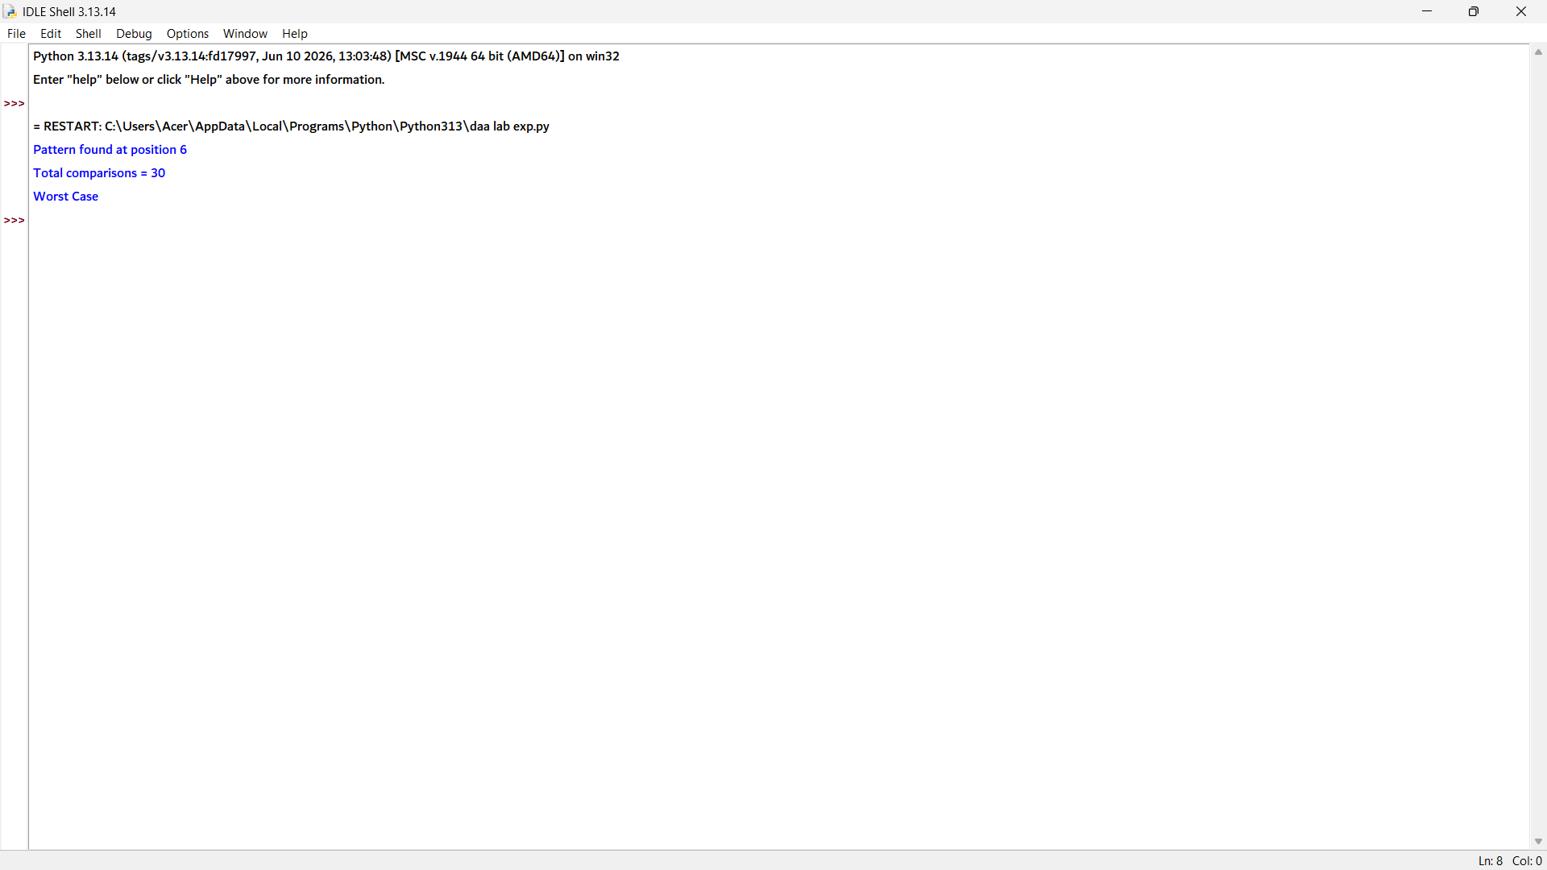

6. text = "COMPUTERSCIENCE"
pattern = "SCI"

n = len(text)
m = len(pattern)

comparisons = 0
found = False

for i in range(n - m + 1):
match = True

for j in range(m):
comparisons += 1
if text[i + j] != pattern[j]:
match = False
break

if match:
print("First occurrence position:", i + 1)
print("Number of comparisons:", comparisons)
found = True
break

if not found:
print("Pattern not found")
print("Number of comparisons:", comparisons)

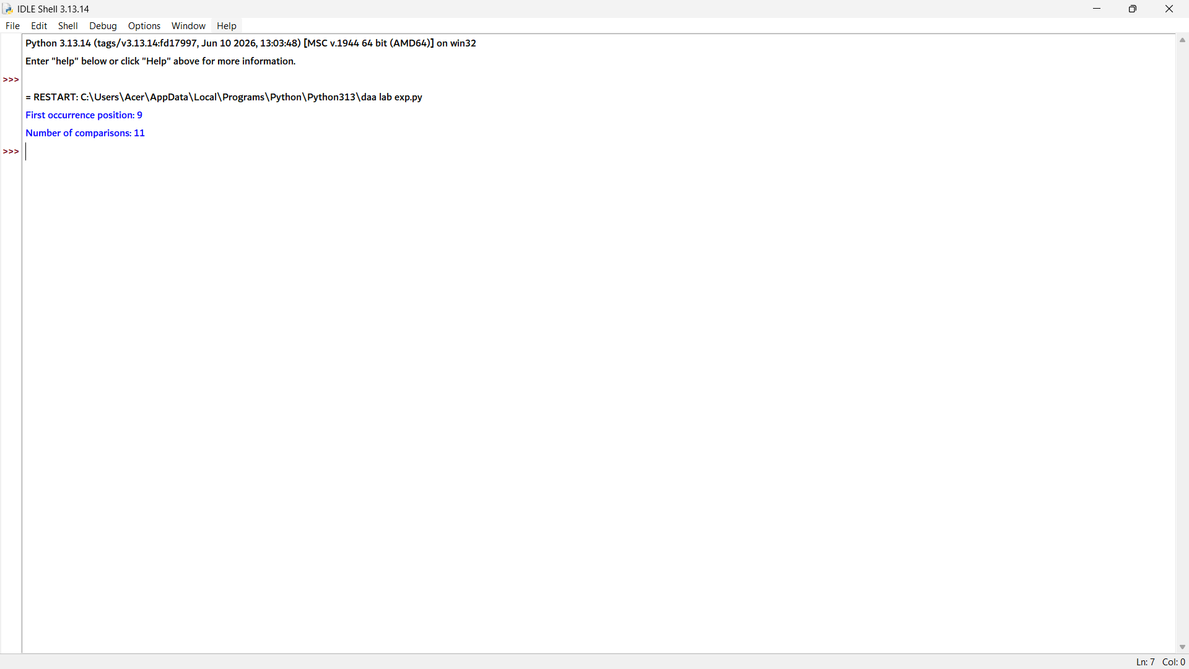

7. text = "DataStructuresAndAlgorithms"
pattern = "ALGORITHMS"

# Convert both to lowercase for case-insensitive comparison
text_lower = text.lower()
pattern_lower = pattern.lower()

n = len(text_lower)
m = len(pattern_lower)

found = False

for i in range(n - m + 1):
match = True

for j in range(m):
if text_lower[i + j] != pattern_lower[j]:
match = False
break

if match:
print("Pattern found at position", i + 1)
found = True
break

if not found:
print("Pattern not found")

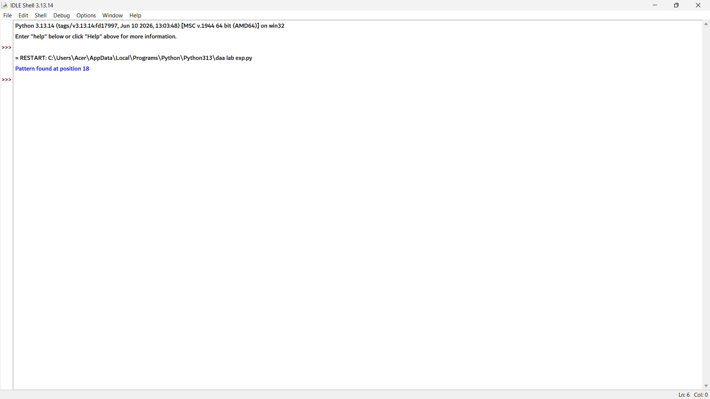

8. def brute_force_search(text, pattern):
n = len(text)
m = len(pattern)
comparisons = 0

for i in range(n - m + 1):
match = True

for j in range(m):
comparisons += 1
if text[i + j] != pattern[j]:
match = False
break

if match:
return i + 1, comparisons # 1-based position

return -1, comparisons

text = "PROGRAMMINGLAB"
pattern1 = "LAB"
pattern2 = "TEST"

# Successful Search
pos1, comp1 = brute_force_search(text, pattern1)

# Unsuccessful Search
pos2, comp2 = brute_force_search(text, pattern2)

print("Successful Search")
if pos1 != -1:
print("Pattern found at position", pos1)
else:
print("Pattern not found")
print("Comparison count =", comp1)

print("\nUnsuccessful Search")
if pos2 != -1:
print("Pattern found at position", pos2)
else:
print("Pattern not found")
print("Comparison count =", comp2)

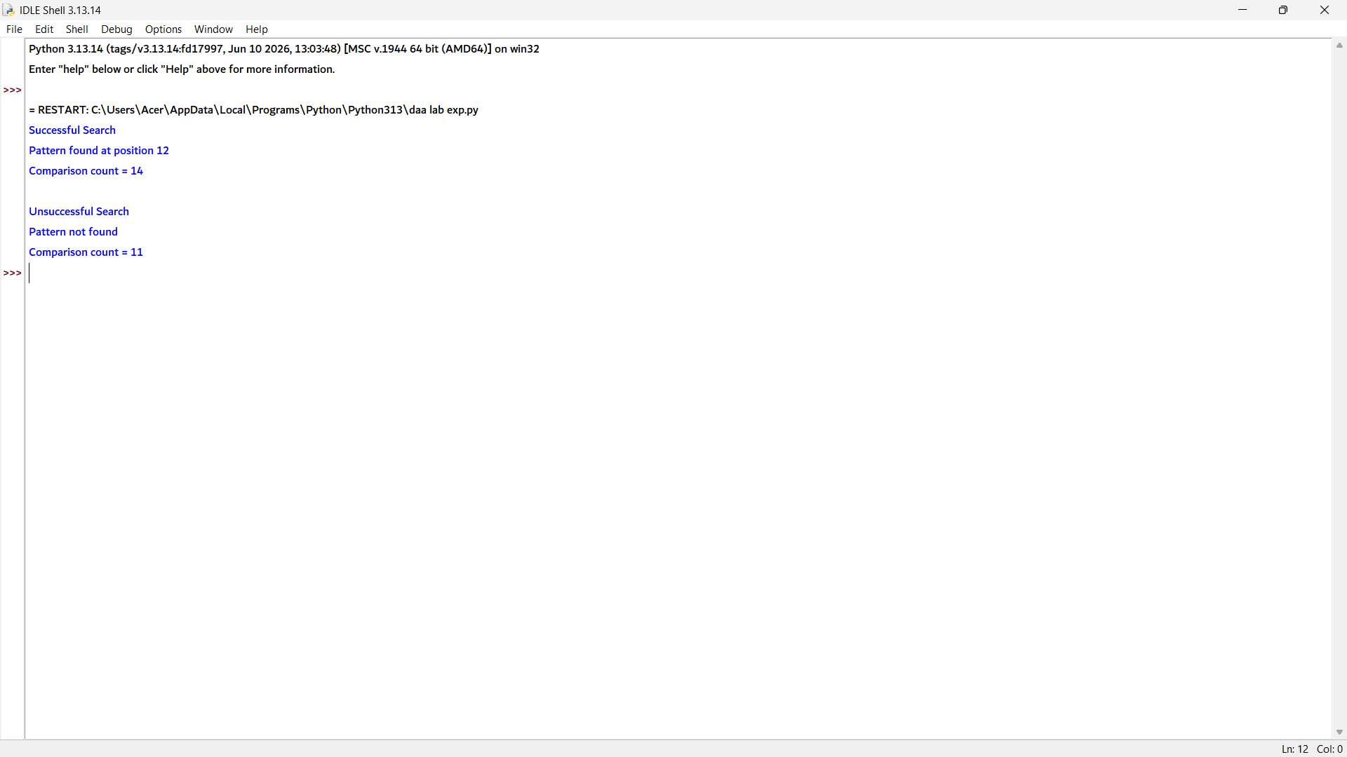

9. text = "ABCDABCABCDA"
pattern = "ABCDA"

n = len(text)
m = len(pattern)

positions = []

print("Alignment\tResult")

for i in range(n - m + 1):
match = True

for j in range(m):
if text[i + j] != pattern[j]:
match = False
break

if match:
print(i + 1, "\t\tMatch")
positions.append(i + 1) # 1-based position
else:
print(i + 1, "\t\tMismatch")

print("\nPattern occurrence positions:")
if positions:
print(*positions, sep=", ")
else:
print("Pattern not found")

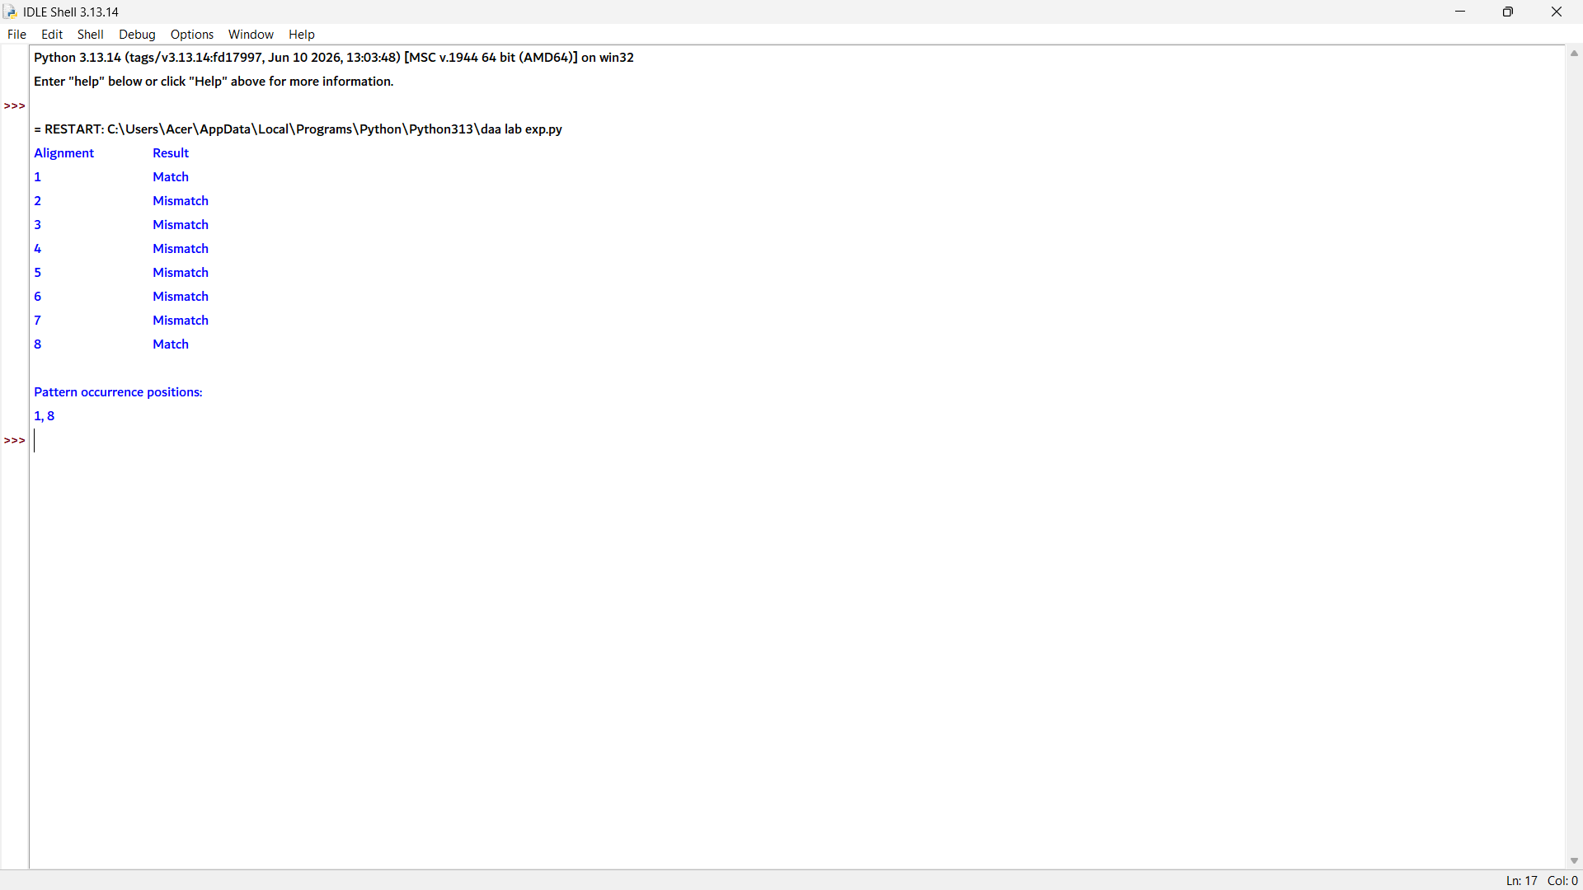

10. text = "TTATAGATCTCGTATTCTTTATAGATCTCCTATTCTT"
pattern = "TATCTT"

n = len(text)
m = len(pattern)

comparisons = 0
positions = []

print("Shift\tResult")

for i in range(n - m + 1):
match = True

for j in range(m):
comparisons += 1

if text[i + j] != pattern[j]:
match = False
break

if match:
print(i + 1, "\tMatch")
positions.append(i + 1) # 1-based position
else:
print(i + 1, "\tMismatch")

print("\nPattern occurrence position(s):")
if positions:
print(*positions, sep=", ")
else:
print("Pattern not found")

print("\nTotal comparisons =", comparisons)

